**SPRINT 4**

|  |  |
| --- | --- |
| Date | 16 November 2022 |
| Team ID | PNT2022TMID15324 |
| Project Name | Project – Smart Farmer-IoT Enabled smart Farming Application |

**CONFIGURATION OF NODE-RED TO SEND COMMANDS TO IBM CLOUD**

Here we add two buttons in UI 1 -> for motor on

2 -> for motor off

We used a function node to analyses the data received and assigncommand to each number.

The Java script code for the analyses is: if(msg.payload===1) msg.payload={"command”: “ON"}; else if(msg.payload===0) msg.payload={"command”: “OFF"};

# Adjusting User Interface

In order to display the parsed JSON data a Node-Red dashboard is created

Here we are using Gauges, text and button nodes to display in the UI andhelps to monitor the parameters and control the farm equipment.

Below images we started to create the flow 1

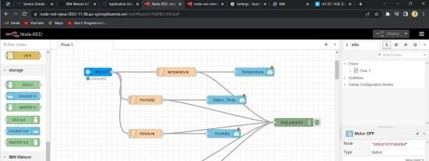

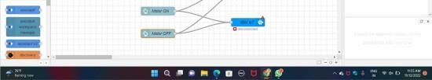

**COMPLETE PROGRAM FLOW :**

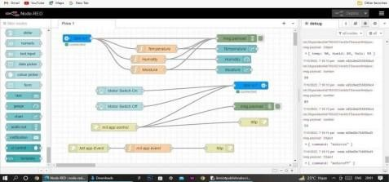

# SCREENSHOTS:

